DAWT ASSIGNMENT-2

SUPERMARKET SALES VISUALIZATIONS

NAME: G.GOWRI PRIYA

Donut Chart – Total sales by payment type

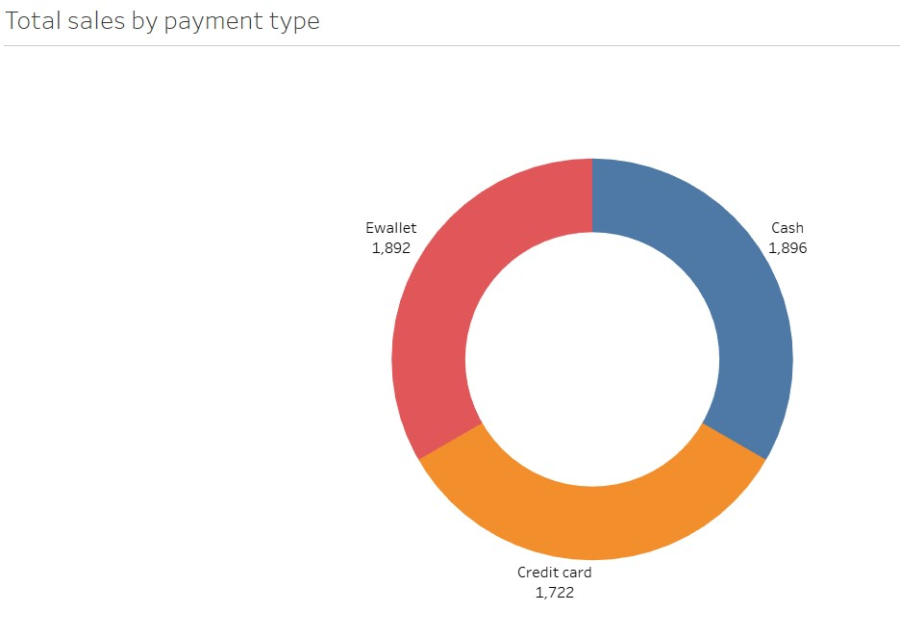

Area Chart – Total sales over time

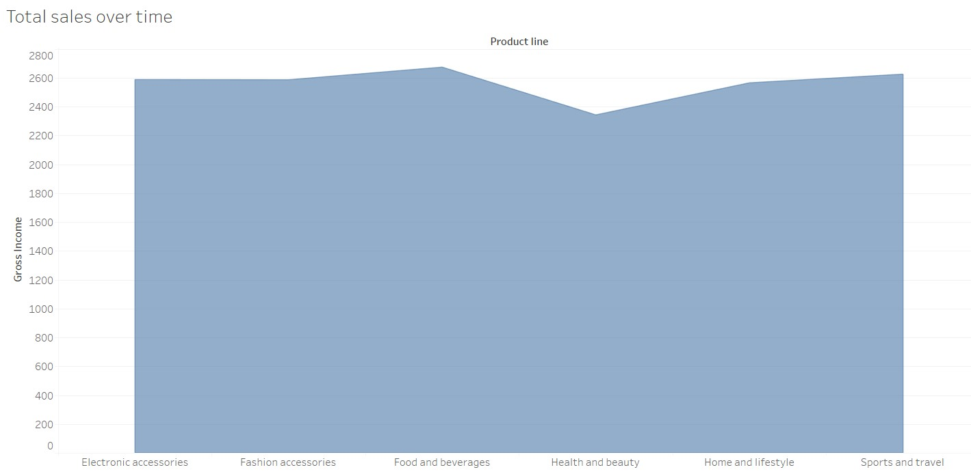

Text table – Gross income by city and branch and gender

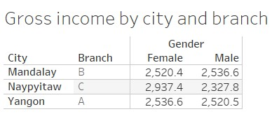

Highlighted table – Customer rating by product line

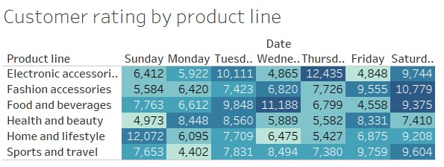

Word cloud – monthly revenue

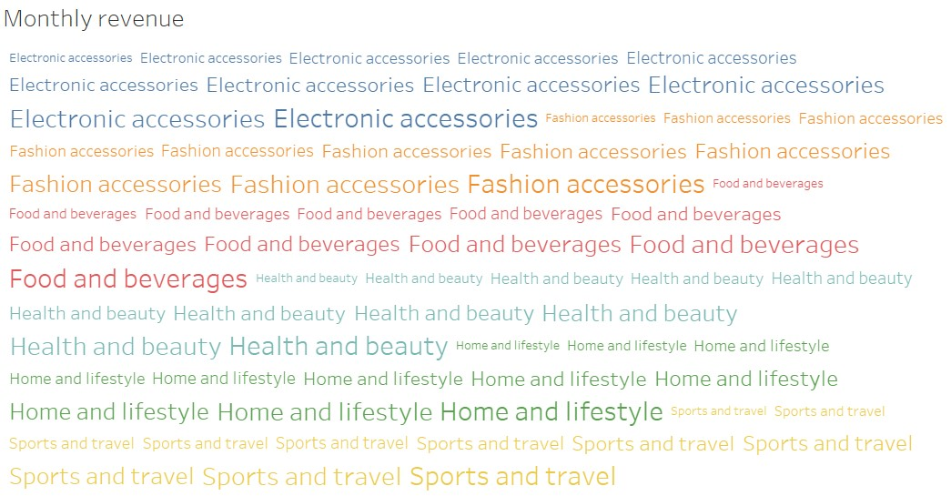

Funnel chart-Gross income by product line

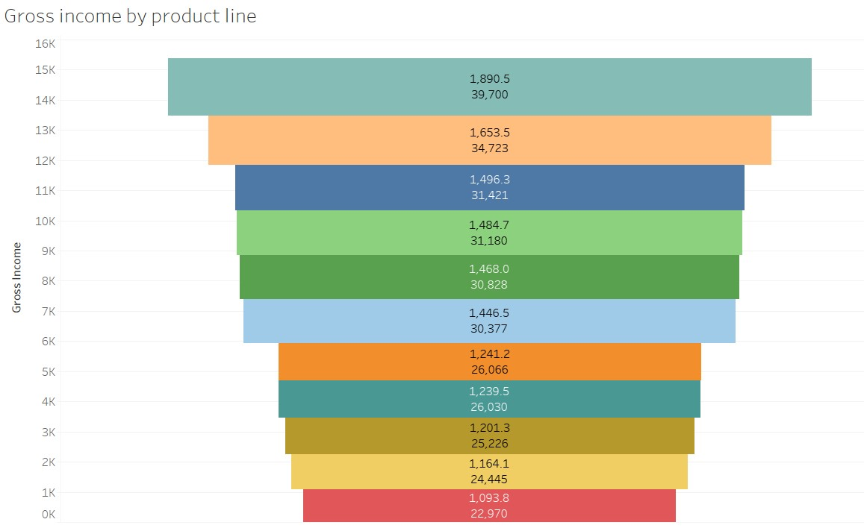

Waterfall-Product line by quantity

